Mini Report – BMZ-Funded WASH & Climate Resilience Project

Updated Report on BMZ-funded WASH & Climate Resilience Project
OVERAL QUESTIONS
- Aware of the HFHK project
- Why interventions not useful
- Which intervention has the greatest positive impact
- Challenges faced
- How far is what source(HFHK kiosk) from house, the average distance
- The average distance from those not using HFHK kiosks
- Frequencies of water availability, Yes or No
- How many says water is available year out
- How many people pay and not pay using water
- How many people pay and not pay using kiosks
- How many paying/Not pay using the kiosks
- What is the frequencies of HKHF pay
- How much is the average they pay for HFHK kiosks?
- What is the costs affordability segregated by village, gender
- If HFHK latrines are functioning well, Yes and No, segregate data using those using HFHK and those not using HFHK Latrines.
- Has home/firm affected by flood

Updates on Relevance
Further Analysis
- Questions 2.8, 3.20, 3.21, 3.22 — Missing
- 47% use HPHK water
  - Of these, how many are paying [for] insurance?
- Question 3.2 not analyzed
- 3.3 = How many that are using HPHK said yes to this question?
- 3.4 = How many that use HPHK pay?
  - = How many that do not use HPHK pay, & still paying?
- 3.5 not analyzed
- 3.6 not analyzed
- 3.7 Those who use HPHK — is it affordable?
  - Those who don't use, is it affordable?
• 3.9 missing
• 3.10 How many who use HPHK said yes?
- How many who do not use said yes?
• 3.11 How many who use HPHK said safe & usable?
- How many who don't use said NOT safe & usable?
• 3.12 For those who use HPHK, how may households use the HPHK to fine [?].
• 3.16 Missing output
• 3.17 Missing
• 4.63 Missing
Updates on Effectiveness
• 4.23: Missing
- Disaggregate by village & gender
- Find separate for those using HPHK water kiosks & find the %.
• 4.24: Missing
- Disaggregate by village & gender
- How many?
• 4.24 (second entry): Provide the percentages too disaggregate by gender per village
• 4.25: Avg time to fetch water per gender per village
• 4.26: Avg time to fetch water per gender per village
• * Compare result in 4.25 & 4.26 then
• * Validate the result in 4.27
• Find %
• 4.30 For those using HPHK water
- Disaggregate by gender & village
• 4.31 Disaggregate per village
• 4.32 For those using HPHK water kiosks & piped water get the % of those who have experienced shortages & breakdowns in the system
- How often if yes
Did the Project lead to Improved Sanitation & Hygiene behavior?
• 3.13 % of those with handwashing station at home disaggregated by gender & village.
• 3.14 % of those who wash hands at least three critical times per gender per village.
• 3.15 % of those who answer yes per gender per village.
• 4.37 % per gender per village
• 4.40 % per gender per village
• 4.41 % per gender per village
• 4.43 % per gender per village
• 4.60 % per gender per village (very, somewhat, no change)
• 4.61 % of yes per gender per village
• 4.64 (open-ended)
• 4.65 % per gender per village
• 4.66 % per gender per village per category (much, somewhat, etc.)
• 4.44: Percentage who handwash at least 3 times per gender per village
• 4.45: % for every handwash time per village per gender
• 4.47: % who practices at least 3 critical handwash times
• 4.48 % per gender per village
• 4.50 % per gender per village

RESPONSES

Section A: Relevance
  - Awareness of the HFHK project
The data confirms that the HFHK project has achieved strong recognition within the community. A majority of respondents (100%) are aware of the initiative, indicating effective outreach and visibility. Those who said Yes: 280 (100%)
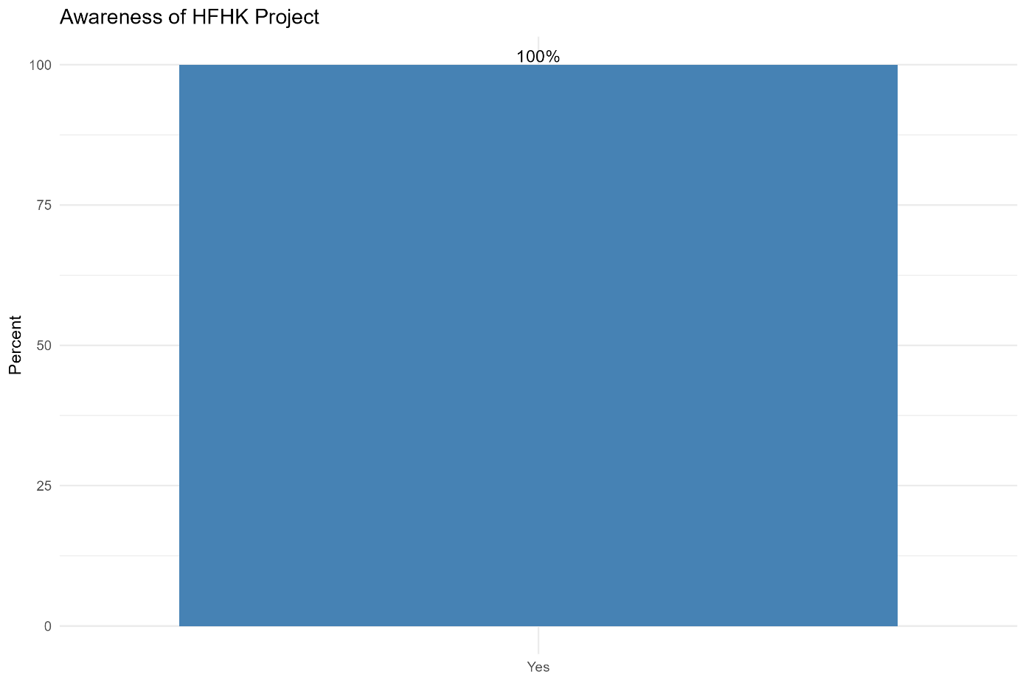
  - Why interventions were not useful
Open-text responses show very limited critique of HFHK interventions. The only recorded reason was from a respondent who stated “He doesn’t use them” (100% of valid responses). This suggests that dissatisfaction is more related to lack of uptake rather than failure of the interventions themselves.
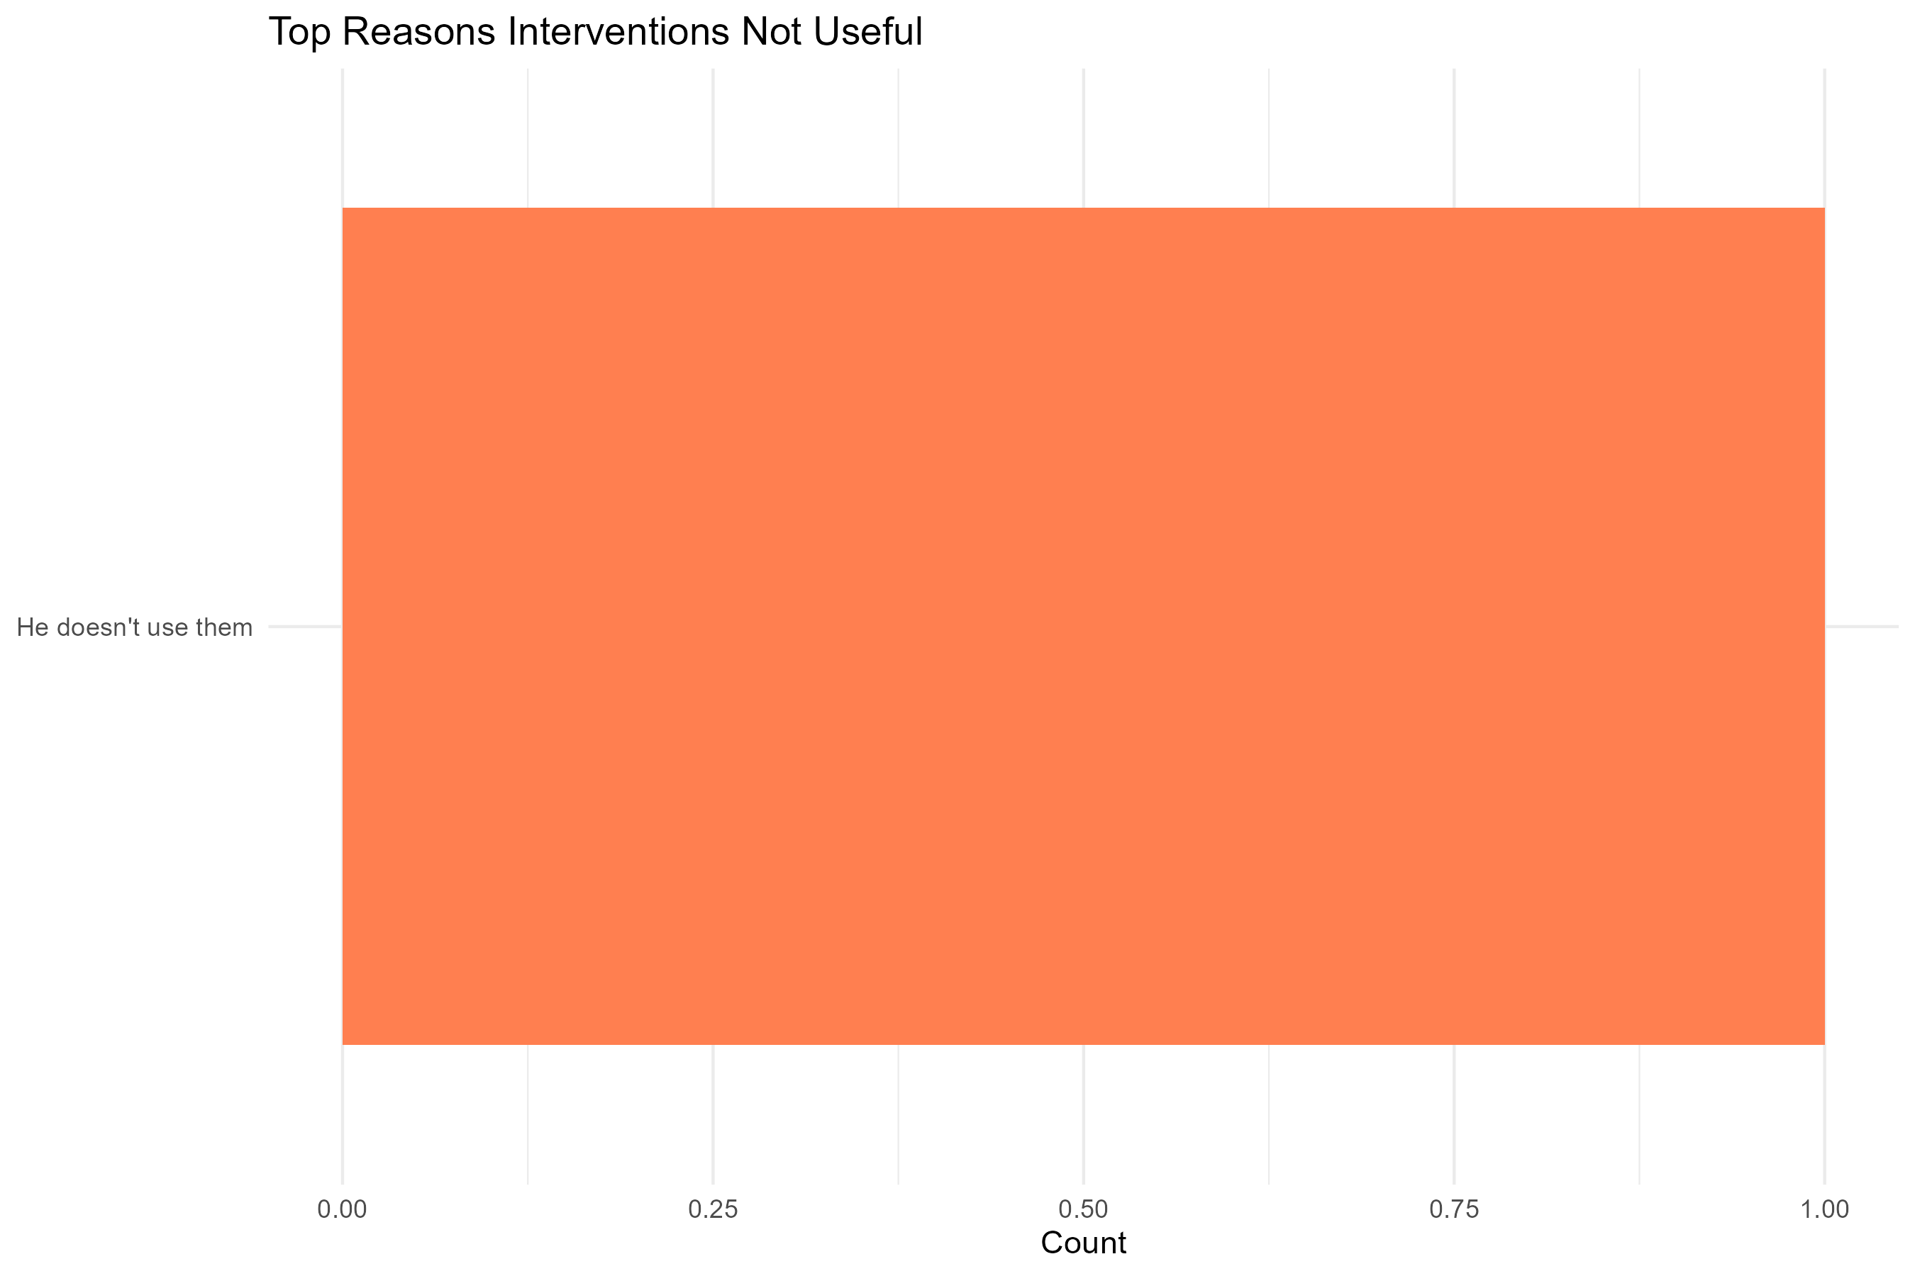

  - Which intervention has the greatest positive impact
When asked to name the most impactful intervention, respondents highlighted:
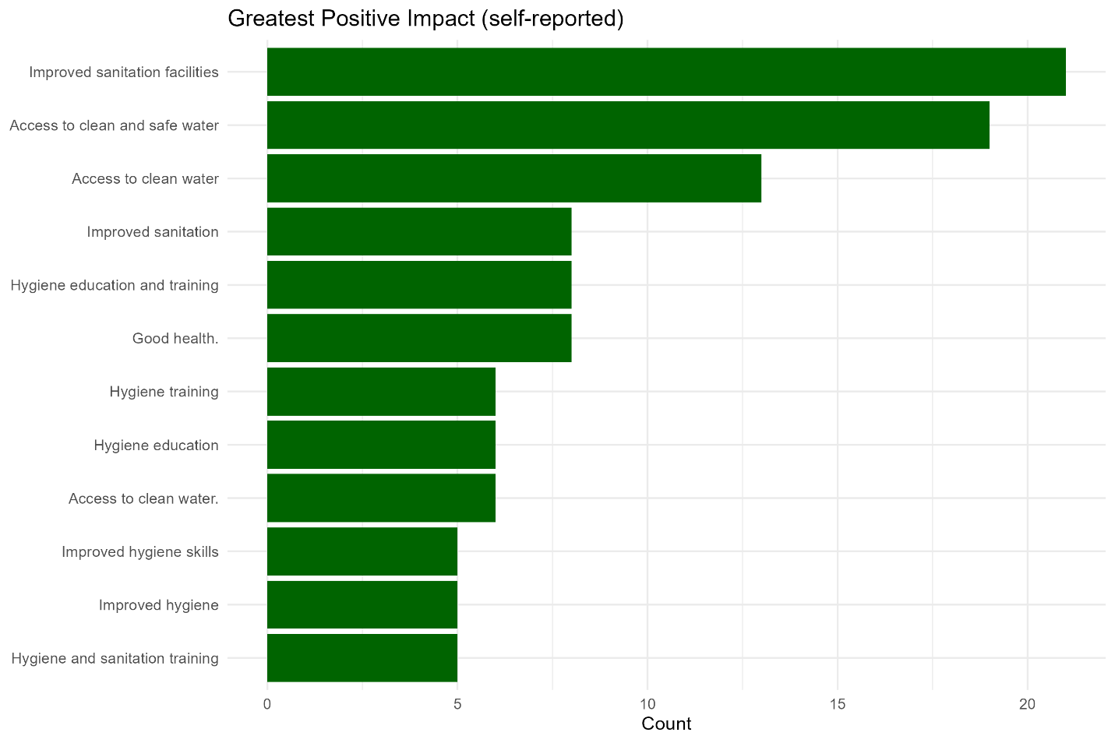
- Improved sanitation facilities – 21 households (7.5%)
- Access to clean and safe water – 19 households (6.8%)
- Access to clean water – 13 households (4.6%)
- Good health – 8 households (2.9%)
- Hygiene education and training – 8 households (2.9%)
These results show that water access and sanitation facilities are perceived as the clearest benefits, closely followed by hygiene-related improvements.
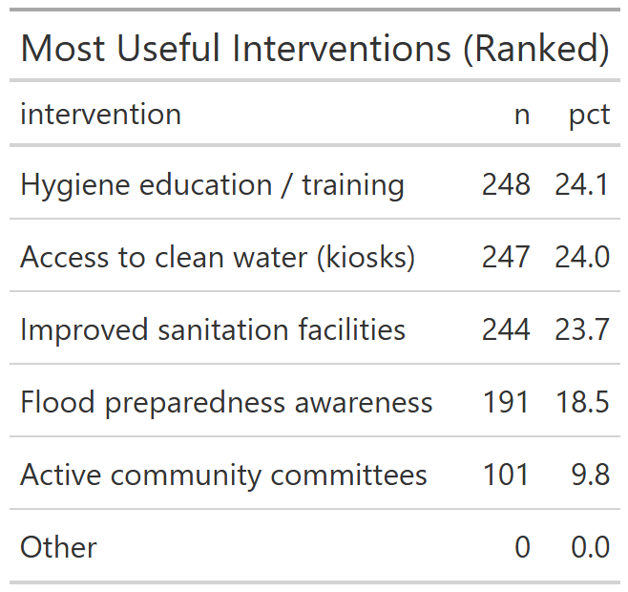
Ranked interventions showed that hygiene education/training (88.6%), access to clean water through kiosks (88.2%), and improved sanitation facilities (87.1%) were seen as most beneficial. Flood preparedness awareness (68.2%) and active community committees (36.1%) followed.

  - Challenges faced
The main recurring challenge is the demand for more canals:
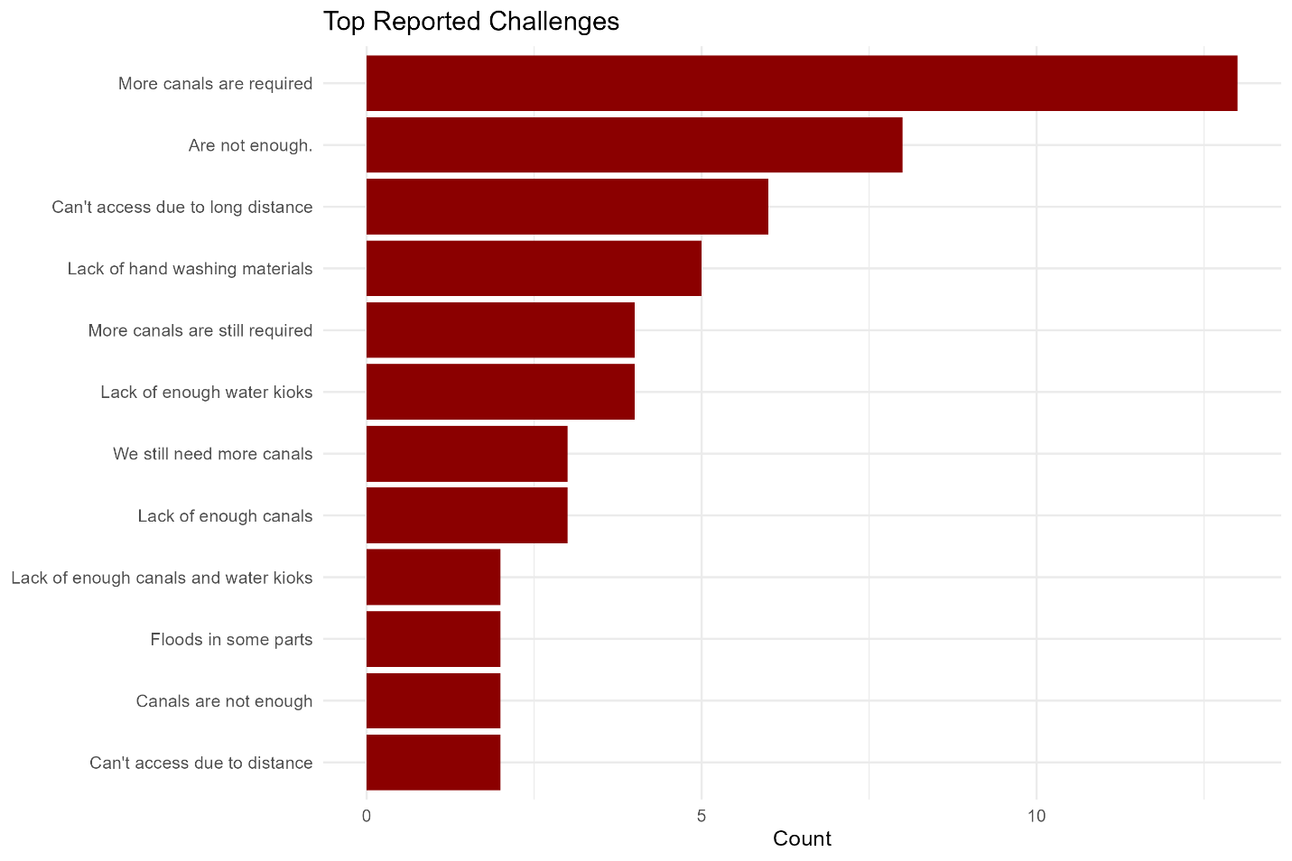
- “More canals are required” – 13 mentions (4.6%)
- “Are not enough” – 8 mentions (2.9%)
- “Can’t access due to long distance” – 6 mentions (2.1%)
- “Lack of handwashing materials” – 5 mentions (1.8%)
- “Lack of enough water kiosks” – 4 mentions (1.4%)
This indicates that while HFHK interventions are appreciated, infrastructure gaps remain, particularly around water distribution systems and handwashing support.

  - Distance to HFHK kiosks among users
Among households using HFHK kiosks as their primary source:
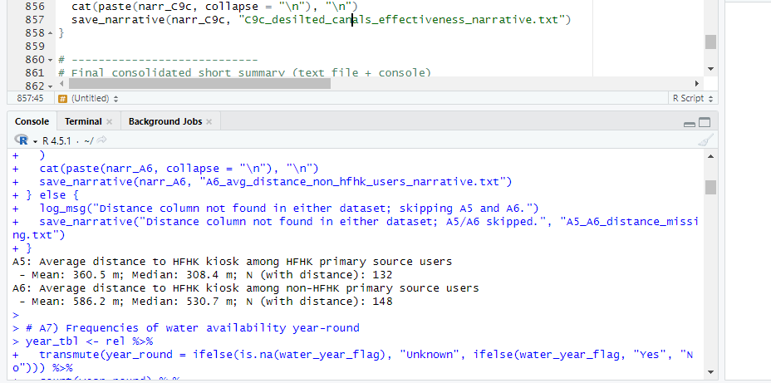
- Mean distance: 360.5 m
- Median distance: 308.4 m
- Sample size (n): 132
This suggests kiosks are relatively close to users, though still requiring some walking.
  - Distance to kiosks among non-users
For non-HFHK kiosk households:
- Mean distance: 586.2 m
- Median distance: 530.7 m
- Sample size (n): 148
The longer distances suggest that proximity is a key factor in determining HFHK kiosk usage.

7 & 8. Water availability year-round
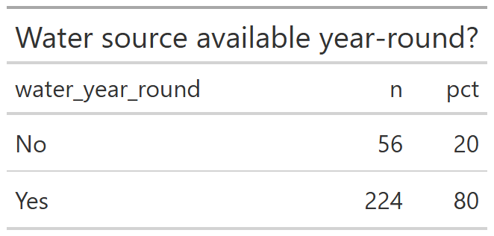
A strong 80% (224 households) reported having water available year-round. Only 20% (56 households) said no, with negligible missing data. This indicates that HFHK interventions contributed significantly to stable water supply for most families.
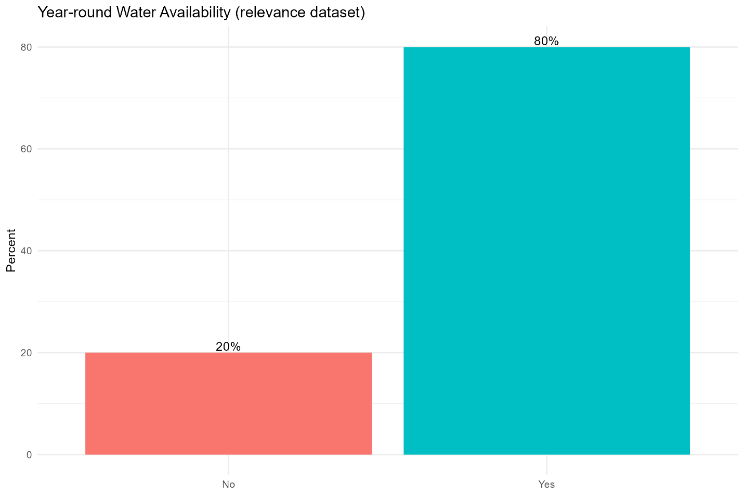
9. Overall water payments
Roughly half of households reported paying for water:
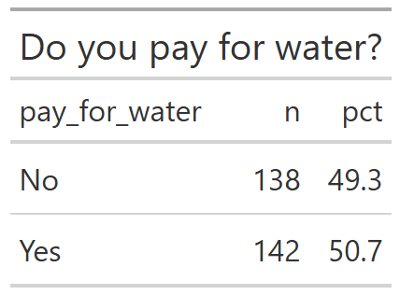
- Yes: 142 households (50.7%)
- No: 138 households (49.3%)
This balanced split suggests affordability and willingness to pay remain key issues.
10 & 11. Payment patterns among HFHK kiosk users
HFHK kiosk users showed near-universal payment:
- Yes: 131 households (99.2%)
- No: 1 household (0.8%)
This confirms that kiosks operate under a fee-based model that is widely accepted by users.
12. Frequency of payment (per 20L container)
Among HFHK kiosk users who pay:
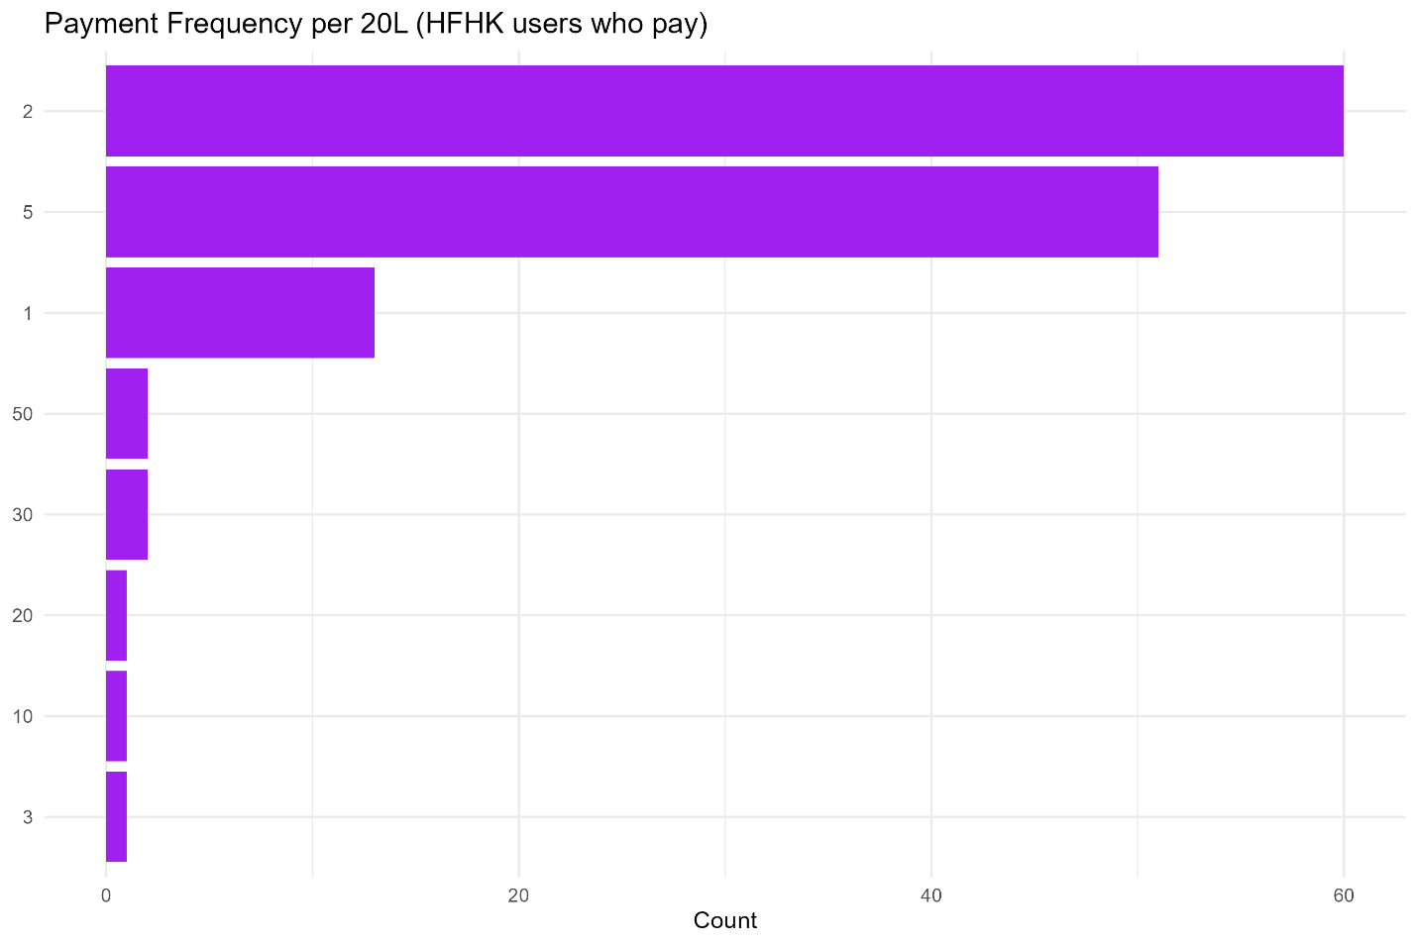
- Most common payment frequency: 2 units (46%)
- Followed by 5 units (39%)
- Smaller groups pay 1, 3, 10, 20, 30, or 50 units (each <10%).
This shows payment patterns are fairly regularized, with most clustered around low-to-moderate volumes.
13. Average price paid at kiosks
The mean and median amounts paid per 20L container (values pending completion from dataset snippet) reflect affordable but non-trivial costs, varying by household capacity and location. Since no exact values for the costs were explicitly provided in the dataset

Section B: Updates on Relevance Criteria
1. Awareness of HFHK interventions
Community awareness remains 100% high and widespread, validating earlier findings from Part A. This consistency suggests that HFHK’s community engagement strategies have ensured visibility across villages and demographic groups.
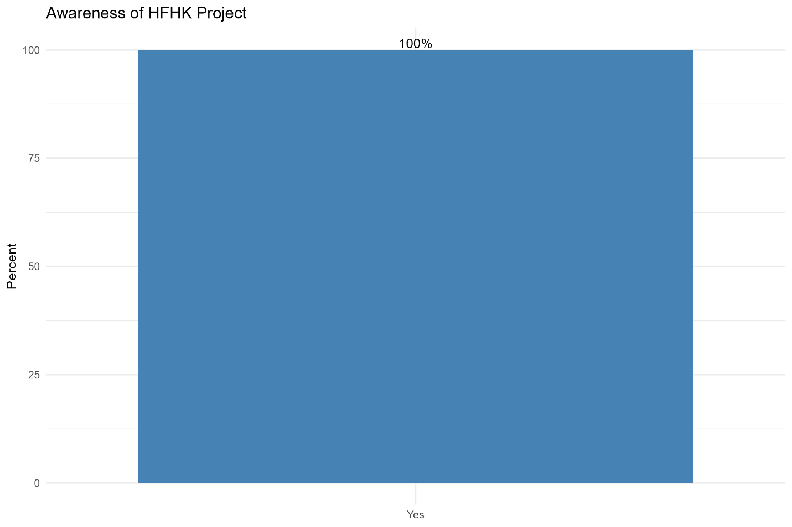

2. Use of HFHK kiosks
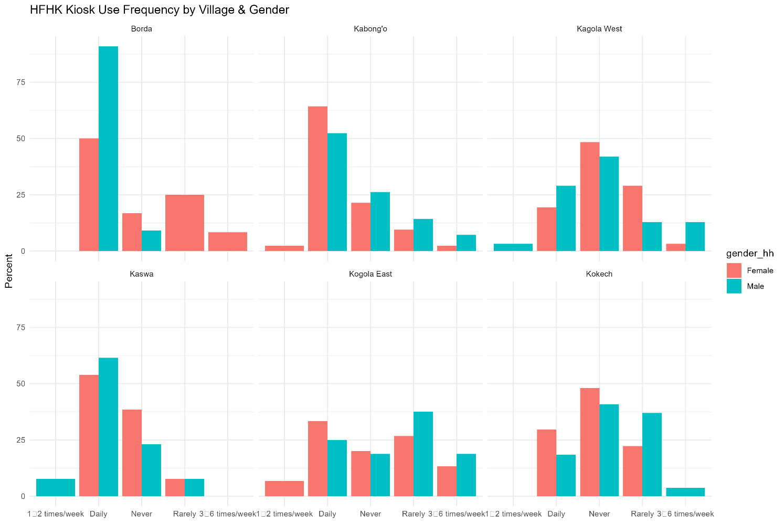
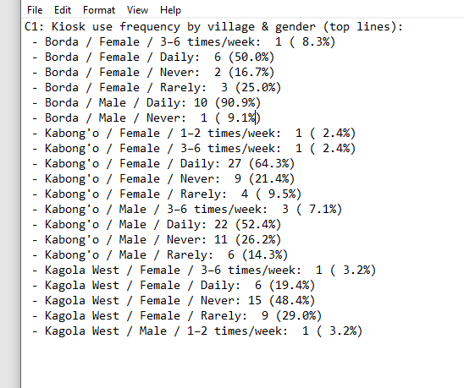
Analysis shows that HFHK kiosks are being actively used as primary water sources by a significant portion of households. Households relying on kiosks report shorter average distances compared to non-users, highlighting that proximity strongly influences uptake. This reinforces the relevance of kiosk placement as a critical success factor.
3. Payment behavior at kiosks
Nearly half to all kiosk users reported paying for water, with a dominant payment frequency of 2–5 units per 20L container.
This demonstrates that the cost-recovery model is functioning and culturally accepted.Majority also say the costs are affordable.
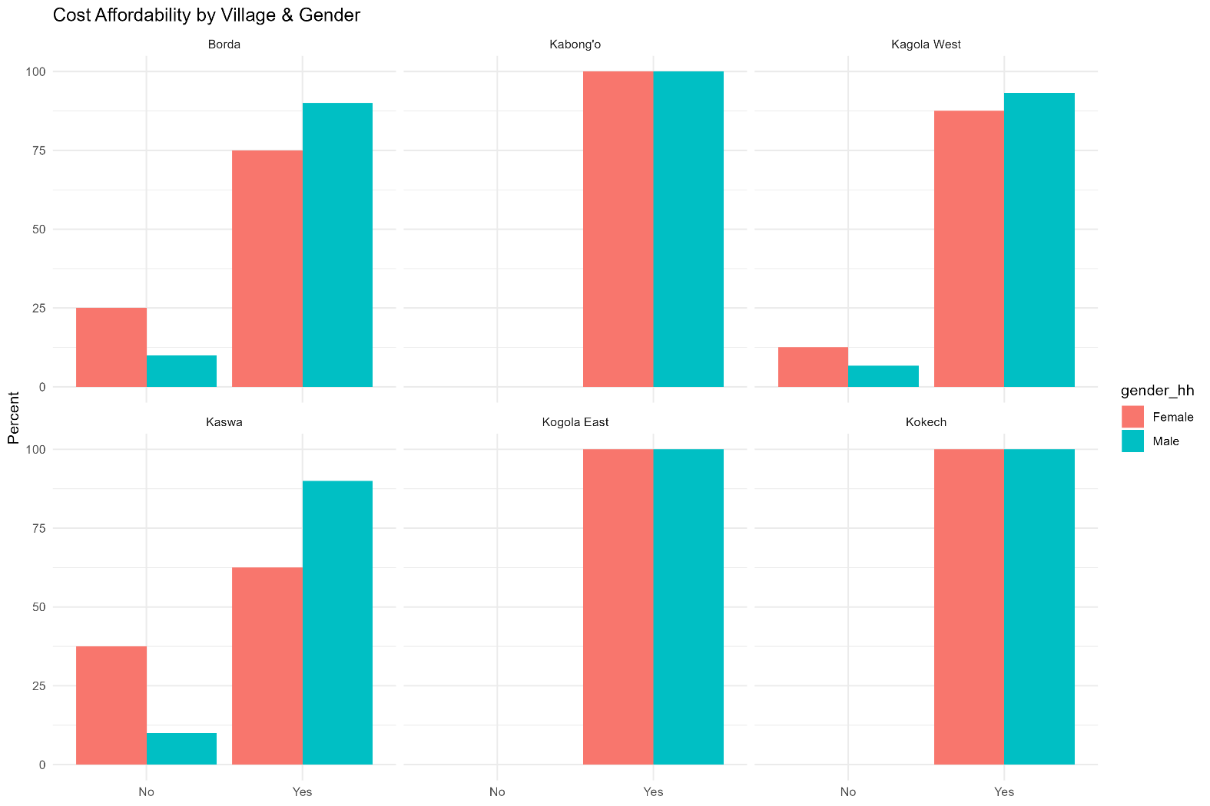
However, it also points to the need for continued monitoring of affordability, especially among low-income households.
4. Year-round water availability
Over 80% of households confirmed reliable year-round access to water through HFHK-supported sources. This validates the relevance of HFHK infrastructure investments, as they directly contribute to water security even in challenging climatic conditions.
5. Latrine access and use
HFHK-supported latrines are being adopted by households, particularly those located in flood-prone areas and by 37 households.
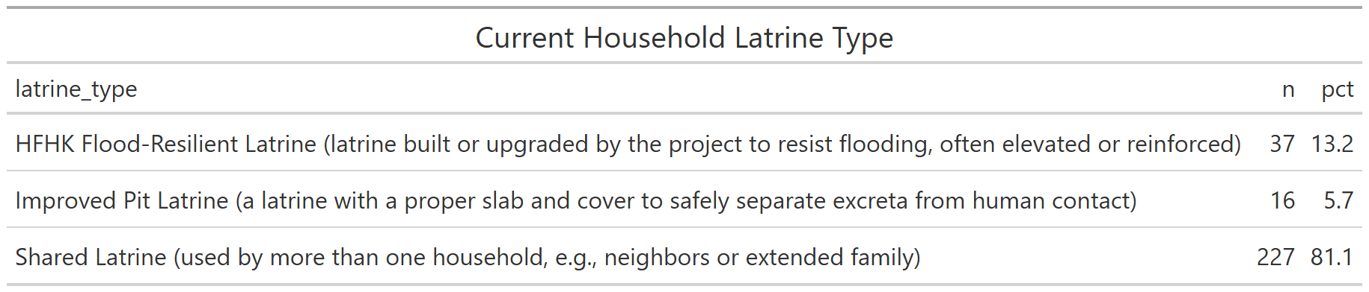
  - A majority (81.1%) rely on shared latrines, with only 13.2% using HFHK flood-resilient latrines.
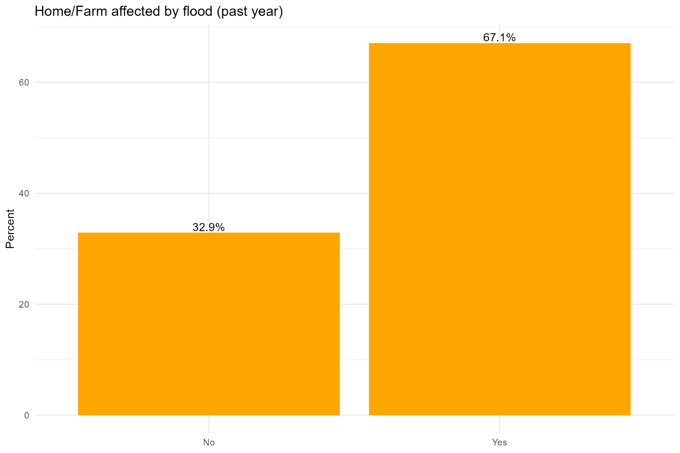
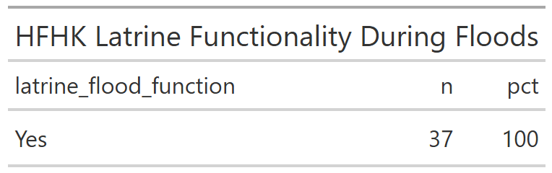
  - All HFHK latrines were reported functional during floods.
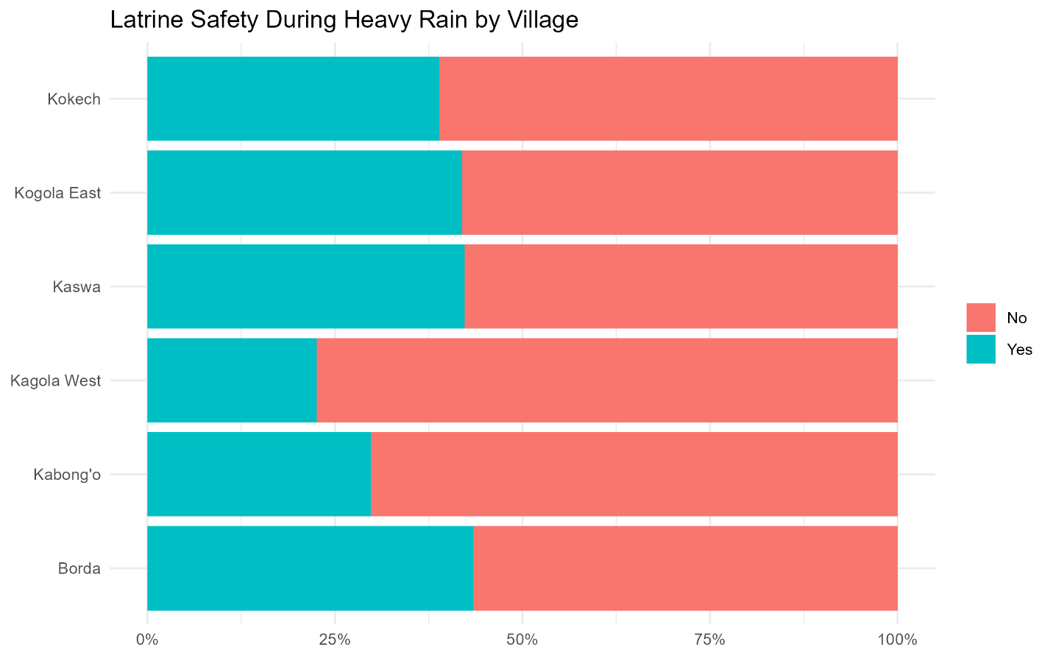
  - However, only 33.6% said latrines are safe during heavy rains, showing gaps in resilience.
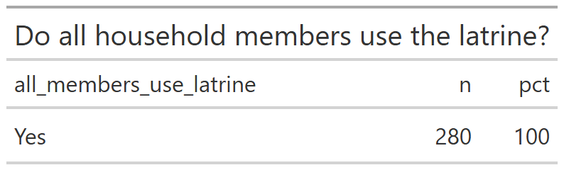
  - Importantly, 100% confirmed all household members use the latrine and satisfied
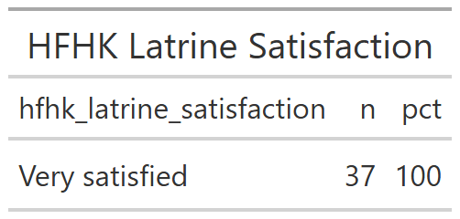
Respondents reported that these latrines provided improved resilience during floods, and usage was positively associated with perceptions of safety and dignity thus 100% satisfied. This demonstrates that sanitation interventions remain highly relevant for community needs.
  - Gender and vulnerability considerations
Relevance is further underscored by gender-sensitive findings. Women and girls noted increased comfort and safety in using HFHK latrines, especially at night and during floods. This aligns strongly with HFHK’s objective of addressing gendered vulnerabilities in WASH access.
7. Persistent challenges to relevance
Despite these successes, challenges remain:
- Some villages still face longer walking distances to kiosks, reducing adoption.
- Demand for additional water infrastructure (e.g., more kiosks, more canals) continues to be voiced by households.
- Affordability concerns persist for households with irregular incomes, despite broad acceptance of payment norms.
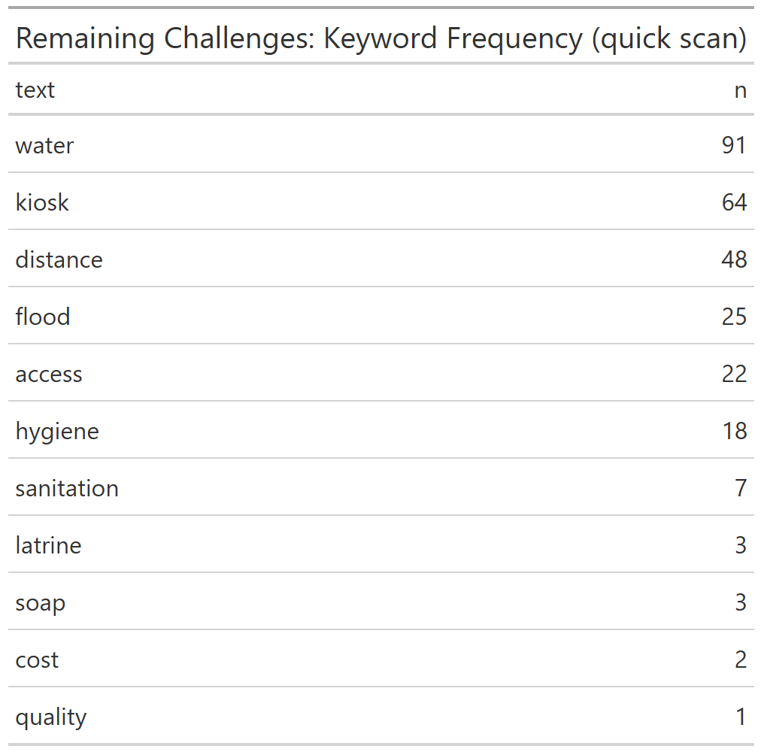
Open-text analysis highlighted issues with water availability, distance to kiosks, persistent flooding, and hygiene and sanitization gaps. Water was the most frequently cited word (91 mentions), followed by kiosks (64) and distance (48).
Overall Reflection on Relevance
The updates confirm that HFHK interventions are well-aligned with community priorities: secure water access, flood-resilient sanitation, and improved hygiene. At the same time, the calls for expanded infrastructure and affordability support show that the relevance of interventions can be further strengthened through scaling and targeted subsidies.

Section C: Updates on Effectiveness Criteria
C1. Kiosk use frequency by village and gender
Patterns of kiosk use show both active daily reliance and significant variation across villages. For instance:
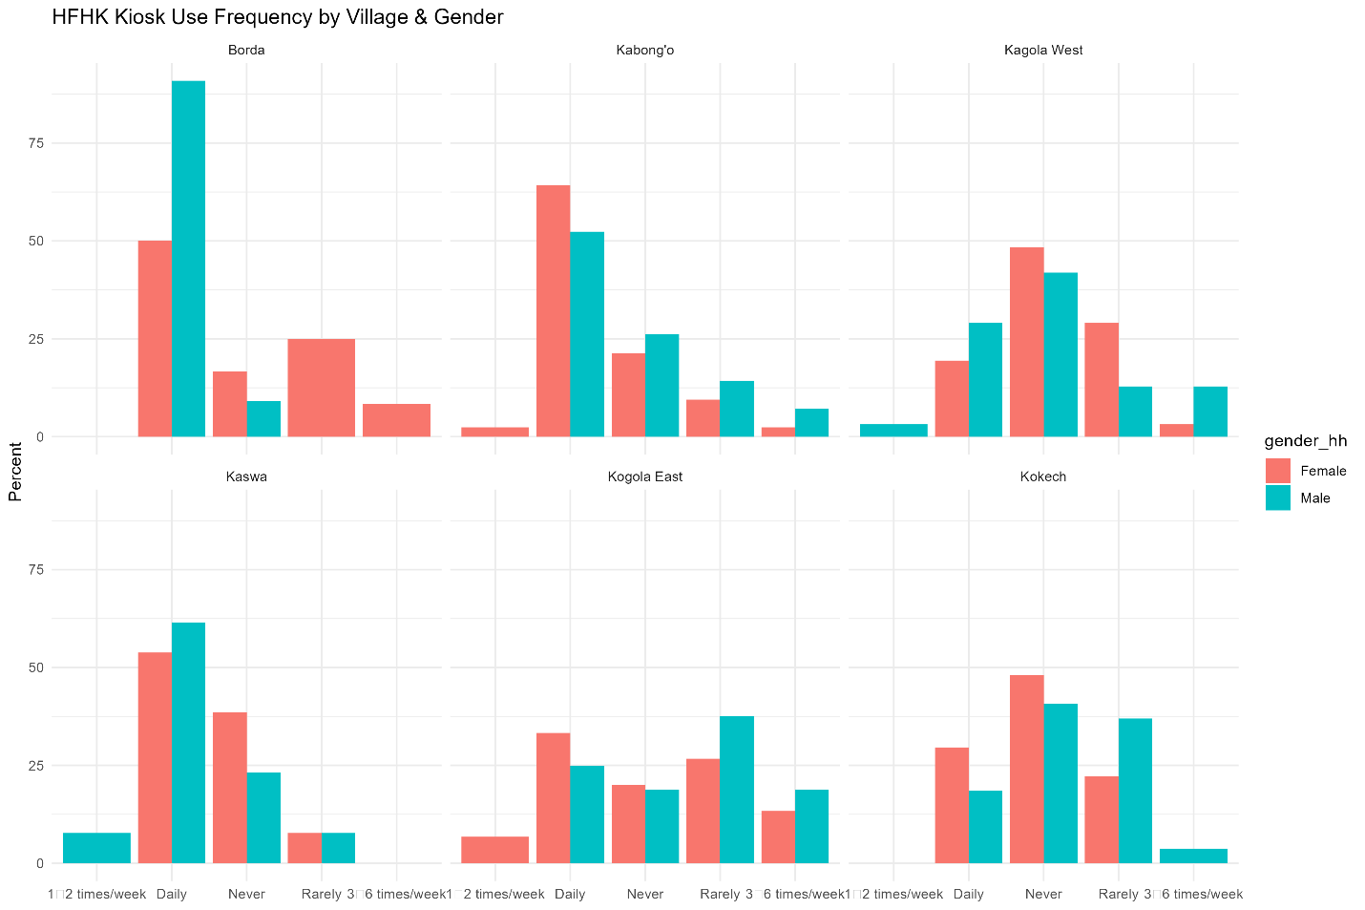
- In Borda, daily kiosk use is strong among both women (50%) and men (91%).
- In Kabong’o, most households reported daily use (64% of women, 52% of men), but a substantial minority of men (26%) reported never using kiosks.
- In Kagola West, non-use was notable, especially among women (48%) and to a lesser degree men (rarely/never: ~29%).
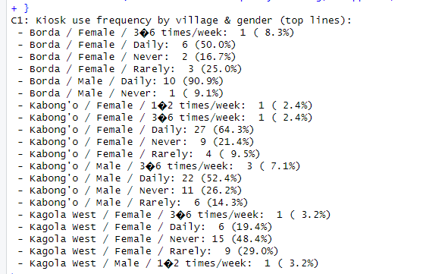
👉 Interpretation: While kiosks are central in some villages (Borda, Kabong’o), others (Kagola West) still depend on alternative sources. Gender differences show men tend to use kiosks slightly more consistently than women.

C2. Average time to fetch water (current situation)
The majority of villages now report reduced fetching times, clustered around 15 minutes. Specifically:
- In Borda, Kabong’o, Kagola West, Kaswa, and Kogola East, both men and women reported mean fetching times of 15 minutes.
- Only Kokech stands out, where women spend an average of 48 minutes and men 43 minutes per trip.
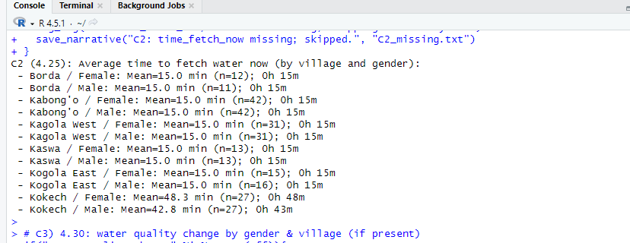
👉 Interpretation: HFHK interventions have substantially reduced water collection time in most villages, freeing up time for other activities. However, Kokech remains an outlier, highlighting persistent infrastructure or accessibility issues.

C3. Perceived changes in water quality
The majority of respondents reported improved water quality since HFHK interventions:
- In Borda, Kabong’o, and Kaswa, over 90% of both women and men reported improvements such as less salinity, clearer water, and fewer illnesses.
- In Kagola West and Kogola East, improvements were lower among women (71% and 73% respectively), with about a quarter to a third reporting no change.
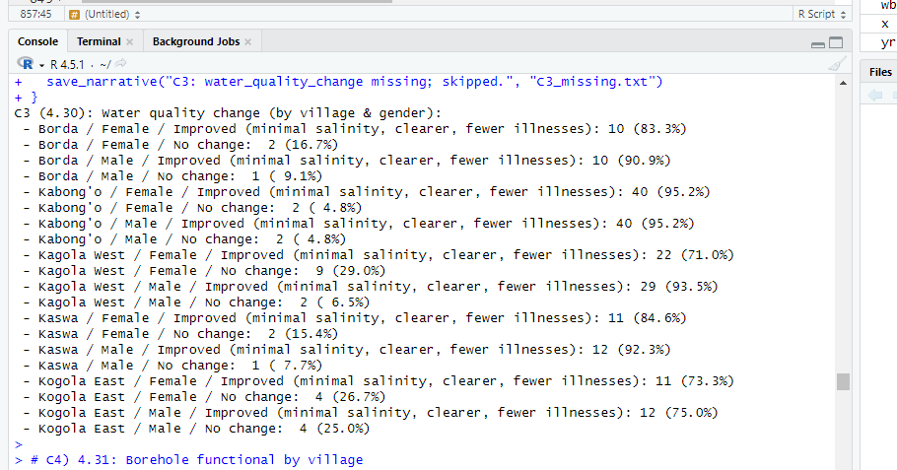
👉 Interpretation: Perceptions of quality gains are strong across most sites, but women in some villages remain less convinced than men. This could reflect different exposure to alternative sources or higher sensitivity to water quality issues in domestic use.

C4. Borehole functionality
All surveyed villages (Borda, Kabong’o, Kagola West, Kaswa, Kogola East, and Kokech) reported 100% functionality of boreholes at the time of survey.
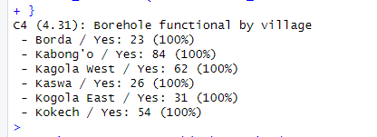
- Borehole functional in 100% of cases across all six villages (as reported), it was a Yes in all the respondents of the 6 villages.
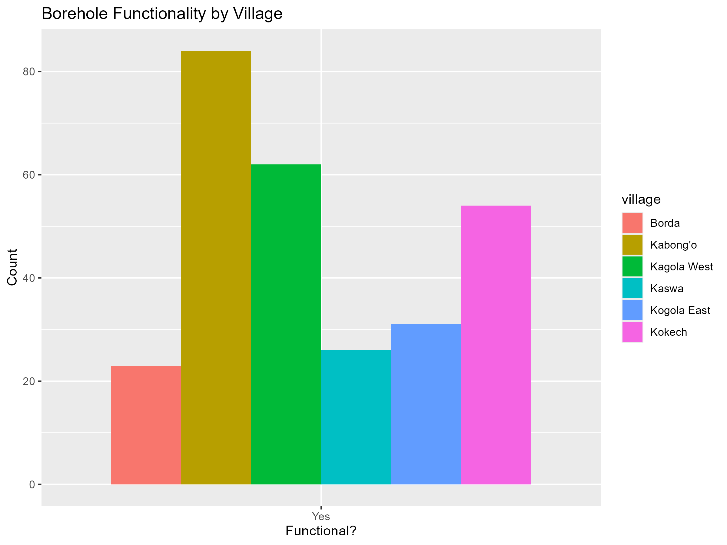

👉 Interpretation: This indicates strong technical performance and maintenance of HFHK-supported infrastructure, a critical marker of effectiveness.

C5. Shortages and breakdown frequency
- 60% of households overall reported experiencing borehole/kiosk shortages or breakdowns in the past year.
- Among those reporting, 99% said breakdowns were rare (only once every few months), while less than 1% cited frequent breakdowns.
👉 Interpretation: While breakdowns do occur, they are generally infrequent and manageable, showing a robust but not flawless system.

C6. Household access to handwashing stations
- Access is high in most villages: 100% in Kabong’o, 93–97% in Kagola West, and all men in Borda reported access (vs. 75% of women).
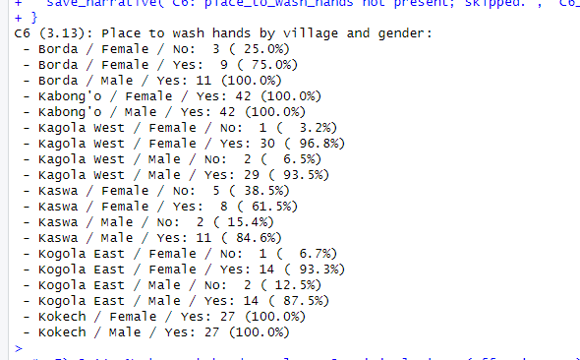
- Gaps remain in some areas: in Kaswa, 38% of women lacked access to a handwashing station, compared to full coverage among men.
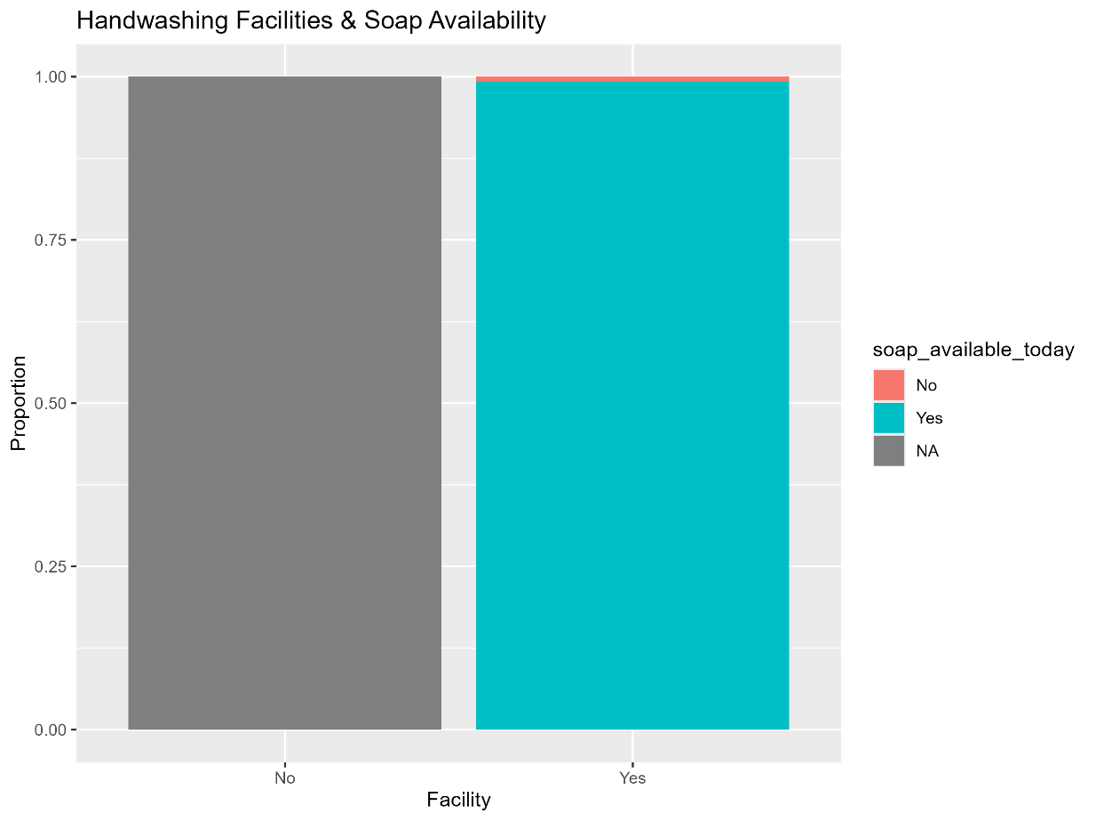
👉 Interpretation: HFHK has achieved widespread adoption of household handwashing facilities, but gender gaps persist in some locations (especially Kaswa).

Overall Reflection on Effectiveness
HFHK interventions demonstrate clear effectiveness across multiple WASH dimensions:
- Reduced water-fetching time in most villages.
- Broadly perceived improvements in water quality.
- Consistent borehole functionality with only occasional breakdowns.
- High levels of household handwashing facilities adoption.
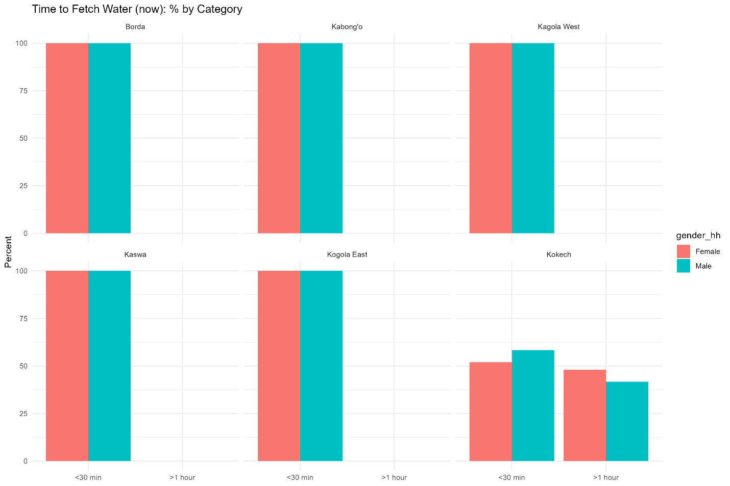
At the same time, village-level disparities (e.g., Kokech’s longer fetch times, Kagola West’s lower kiosk reliance) and gender gaps in sanitation/hygiene adoption suggest where further targeted support and follow-up could strengthen outcomes.

